**Using Basic Desktop Publishing creating letterheads**

**Enter Your name:**

Two (2) marks for each correct answer

Word Processing

To ensure that documents belonging to an organization are consistent and include correct, relevant information (logo, contact details and text styles) we create a letterhead and style sheet. This ensures that the information will be placed correctly and appropriately in the document.

To create text documents on a computer we use a word processor rather than a text editor. A text editor stores the ASCII characters in a data table of character position and ASCII value. A word processor has a similar basic function, however each character has large amounts of metadata held in the array as well.

Touch typing is a good skill to possess – use a typing tutor program to practice such as TypeQuick or Typing Tutor. Touch-typing allows for the quick entry of original text data. If hard copy exists then scanning and OCR is often an appropriate method. Speech to text recognition software, is include on a Mac Word processing like Word, or such as Dragon Naturally Speaking or Point and Speak Voice Recognition, can speed up the process of text entry for slow typists.

Word Processing Documents

As most documents created in a word processor are meant to be viewed as hard copy (printed on paper) the basic word processing applications tend to be WYSIWYG. Use the Print Layout option on the View menu to see how the document will looked in printed format as you are creating it. This is important if you are drawing objects such as a flowchart.

Tip If you need to change the settings of the various document sections use the File - Page Set-up Menu.

Document Templates

To allow for quick development of complex documents and to keep uniformity within the commercial environment, templates are often created. You will need to create your own template to use as a basis for the rest of the task.

Part 1

For this task you are going to create a letterhead for your school/college and then store it as a template.

Here is an example of a letterhead. Look at the sample letterhead before you attempt to create your own.

Example of a letterhead

**SAMPLES LETTERHEAD**









Instructions

Use the Find facility to locate the document templates (*.dot) used by MS Office. Note the location.

Open MS Word.

1. Open Microsoft Word create a page in portrait A4 size

2. Use your existing product details to create a Letterhead

3. Add text box change colour and fit the box as header

4. Insert another text box and type text which should be put over the first text box, this is the details of your letterhead, it should incorporate:

Name of Company, address, phone, web and Email details

5. Your page needs some colour down one side or across the top to add impact

~ File – New Create New – Template

~ File - Page Set-up: paper size, margins, different first page, orientation

~ Format – Font: font set, size, style

~ View - Header and Footer: School (or your) name, subject, year

***Tip --Most of the items below will be found on the Tool Bar or in the Insert Menu***.

~ Footer: auto-text filename, page number, date NB--use the tab key to move the cursor in your footer.

~ Save.

Part 2 Create more templates

Now that you have created a template, create a series of templates suitable for the Work Placement organization you have worked with or another organization that you are familiar with. Once a number of suitable items are created, look for consistent objects and link them to a single data source (e.g. logo, header, etc.)

NB You will need to create the logo and then insert it as an object that is linked.

You will need to draft a “rough” sketch by hand for each before you create the documents. Remember to develop a consistent “feel” for the set of documents that your Work Placement organization or other organization would use.

Examples of suitable documents could be: (pick one)

~ intra-office memo

~ official correspondence

~ office newsletter

~ fax cover sheet

~ monthly report

~ section report

~ entry on duty data sheet

~ accident report form

~ order form

~ purchase request form

6. Add a graphic from your product and place this in a text box in the header and footer area, make the graphic watermark or slightly transparent

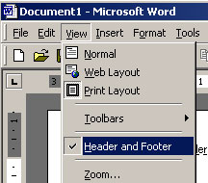

7. Select a picture and click on Format Picture

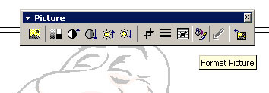

8. Make the picture Watermark or try other settings

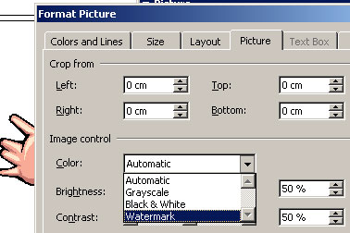

9. Save the file as letterhead.doc

At the End of this Lesson

### Students will

1. Plan and implement ideas for presentation
2. Design and create a Presentation for a product
3. Use skills to add images and animations
4. Plan for a target audience based on a theme

Create a cover document made up of text and pictures